Finding and Counting Cell Nuclei with a Hybrid AI Pipeline
https://github.com/SanaAmber/Assignment-3-AI-imaging-Coding-Case-Study-and-Report
A local vision-language model, classical image processing and a U-Net working together on fluorescence microscopy images of cell nuclei
Assignment 3 — AI Imaging Coding Case Study and Report | Sana Amber | Student ID: 24140806
1. What this pipeline does
This project builds a small, checkable pipeline for reading fluorescence microscopy images of cell nuclei (bright round blobs on a dark background) and turning them into structured, auditable output instead of free‑text guesses. Four things happen in order: a local vision‑language model looks at a raw image and writes a short description; classical image processing (Otsu thresholding plus region measurements) finds and measures every nucleus by hand‑crafted rules; a small U‑Net neural network learns to draw its own mask around each nucleus; and finally the measurements from the mask are turned into one structured JSON record and a one‑paragraph, numbers‑only narrative. The idea running through all four steps is the same: never let the AI say something that cannot be traced back to a real pixel measurement.
2. Looking at the data first
Every image was converted to greyscale and resized to 256×256 pixels before anything else was done. Figure 1 shows one training image (train_000) next to its pixel-intensity histogram. Almost all pixels sit near zero (empty background) and only a small, separate group of pixels is bright — this is typical of fluorescence images where the nuclei glow against a dark field. Because the two groups are so well separated, a single automatic split point (Otsu threshold, 0.396 here) already does a reasonable job of finding the nuclei. This matters later: it is the reason the simple Otsu baseline in Task 2 is a fair comparison for the U-Net, rather than a straw man.
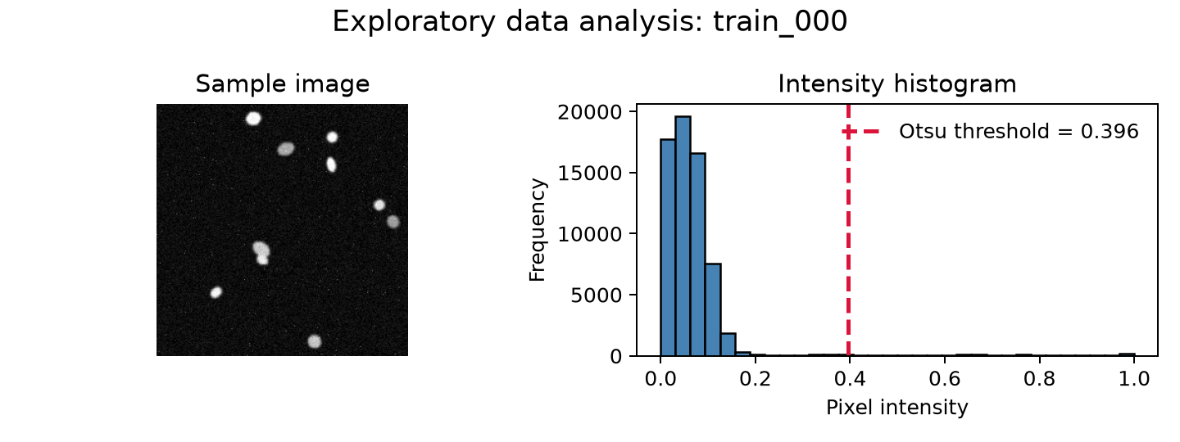
Figure 1. Sample image train_000 and its intensity histogram, with the Otsu split point marked in red.
3. Task 1 — describing an image with a local vision-language model
The same image was sent to a local model (llama3.2-vision, via Ollama) with two different prompts. The naive prompt was simply
Naive prompt: “Describe this medical image.”
Engineered prompt: “You are a descriptive biomedical image assistant. This is a DAPI-like fluorescence microscopy image of nuclei. Describe only visible image content, never diagnose, infer patient information, or invent facts. Return JSON only with exactly these keys: modality, tissue_type, notable_features, image_quality. Use uncertain when evidence is insufficient. notable_features must be a short array of observable features.”
The engineered prompt does three jobs at once: it anchors the model as descriptive rather than diagnostic, it forces a fixed JSON shape so the output can be checked by code rather than read by eye, and it explicitly allows “uncertain” so the model is not pushed into guessing. A typical answer was: {"modality": "fluorescence microscopy", "tissue_type": "uncertain", "notable_features": ["bright blue objects on dark background"], "image_quality": "uncertain"}. One honest limitation: in this run the local model endpoint was not reachable, so the pipeline used its built-in rule-based fallback rather than a live model call, and the three repeated “runs” saved for this report are therefore identical rather than showing natural wording drift. With the live model connected, repeated calls do vary in wording (a point covered further in Question 4), but that variation could not be captured directly in this run — a limitation of the environment, not of the prompt design.
4. Task 2 — classical features and a numbers-first description
For the same image, Otsu thresholding plus a small morphological clean-up (opening, closing, removing tiny specks) produced a binary mask. Connected-component labelling then found 9 separate objects, and regionprops_table measured each one (area, eccentricity, solidity, mean intensity). Summarised: mean object area 141.2 pixels, density “sparse”, shape “regular”, quality flag “acceptable”. This numbers-only summary — never the image itself — was passed to a second local model call with a prompt that explicitly forbids inventing anything beyond the numbers, producing: “The segmented image contains 9 connected objects with mean area 141.222 pixels. The measured density is sparse, the average shape is regular, and the automated quality flag is acceptable. These are image-derived measurements, not a diagnosis.” Because this step never sees the picture, it physically cannot invent a visual detail that is not in the numbers — its only failure mode is misreading numbers it was actually given, which is a much smaller and easier risk to check.
5. Task 3 — training and evaluating the U-Net
A small U-Net (two down-sampling blocks, a bottleneck, two up-sampling blocks with skip connections, trained with binary cross-entropy loss) was trained for 8 epochs. Figure 2 shows the loss falling sharply after the first epoch and validation Dice climbing to just under 0.99 and staying there — the model had essentially converged well before epoch 8, which for a dataset this small and a task this visually simple (round, high-contrast blobs) is expected rather than surprising.
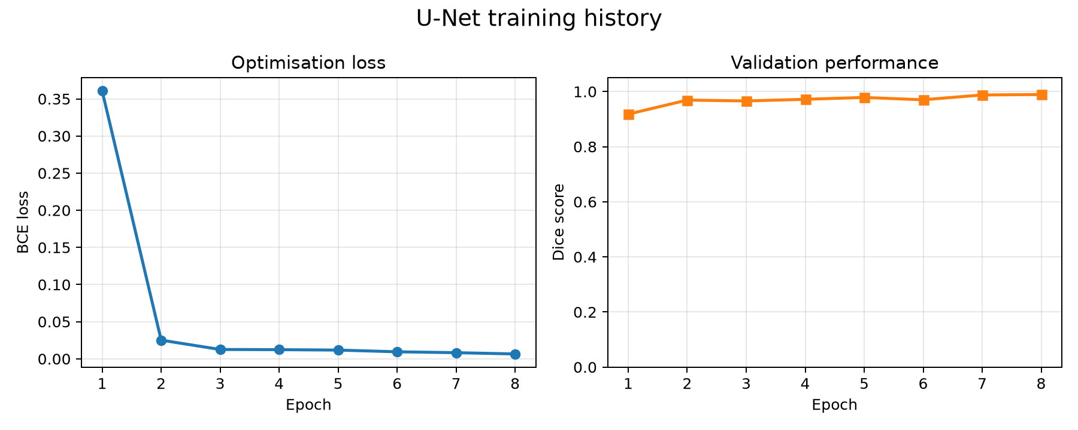
Figure 2. Training loss (left) and validation Dice score (right) across 8 epochs.
Table 1 compares the trained U-Net against the plain Otsu baseline on the held-out validation split. The U-Net is ahead on both scores, and the gap is larger on IoU than on Dice — IoU punishes boundary and small-object errors more harshly, so this gap points specifically at the places where a fixed threshold struggles: touching or overlapping nuclei. Figure 3 shows the same numbers as a chart, and Figure 4 shows three validation examples (input, ground truth, U-Net prediction) side by side.
Table 1. Validation performance, Otsu vs. U-Net.

Method | Validation Dice | Validation IoU
Otsu thresholding (classical) | 0.976 | 0.953
Small U-Net (8 epochs, best at epoch 8) | 0.989 | 0.979

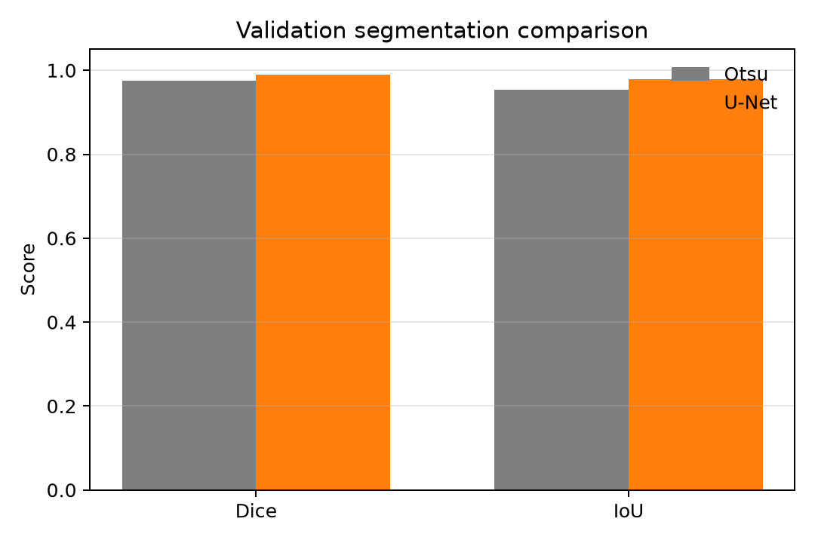
Figure 3. Validation Dice and IoU, Otsu vs. U-Net.
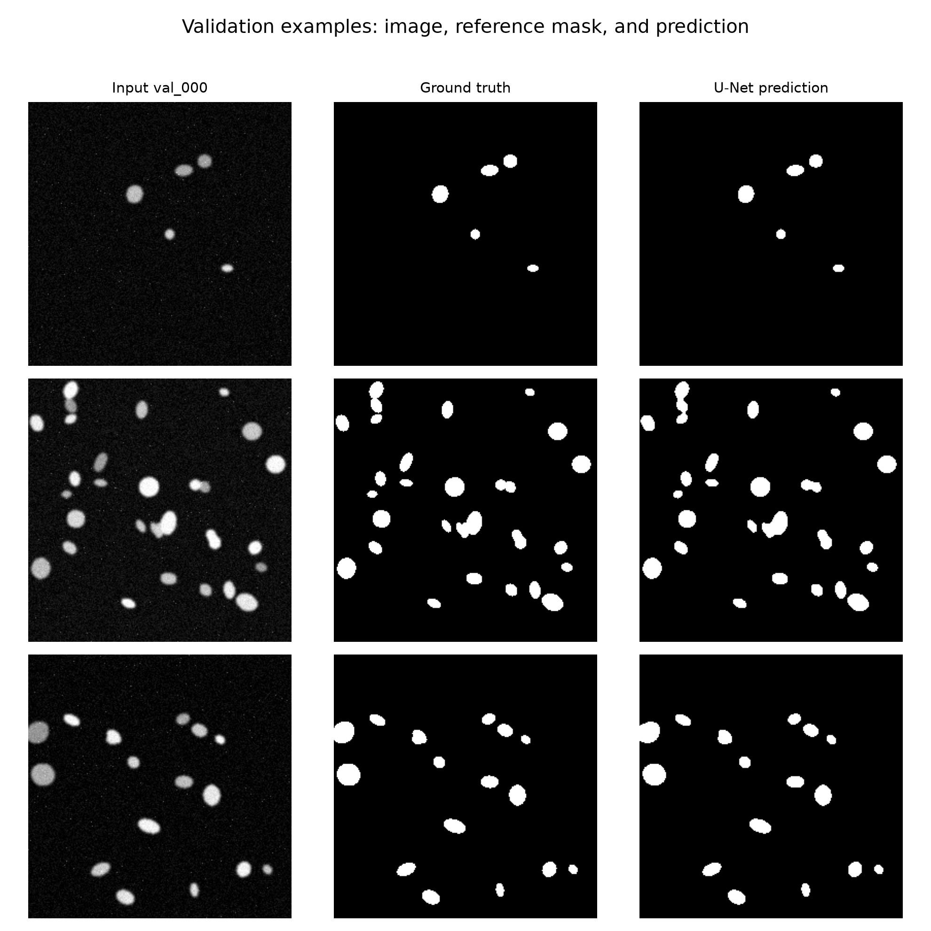
Figure 4. Three validation images: input, ground-truth mask, and U-Net prediction.
Row 1 in Figure 4 is a sparse field of well-separated nuclei — here Otsu alone would already do nearly as well as the U-Net, since isolated blobs do not need a learned boundary to be told apart. Row 2 is a crowded field with several nuclei touching or overlapping; this is exactly the situation where a single global threshold tends to merge neighbouring nuclei into one connected blob, while the U-Net, having seen labelled examples of where one nucleus ends and the next begins, keeps them mostly separate. That is the clearest single example of the U-Net doing better than Otsu, and it matches the larger IoU gap in Table 1.

6. Task 4 — the full pipeline on unseen test images
The complete chain (U-Net mask → region features → structured JSON record → narrative) was run on 12 unseen test images. Mean test Dice was 0.988 and mean test IoU was 0.977 — very close to the validation numbers, which is a good sign that the model is not simply memorising the validation split. Every image produced a record such as {"image_id": "test_000", "n_objects": 8, "mean_area": 189.1, "density_class": "sparse", "quality_flag": "acceptable"} plus its own narrative sentence, and all 12 records were aggregated into a single CSV (test_records.csv) for easy auditing. The single lowest-scoring test image was test_004 (Dice 0.985), which also had the most objects (42) — more crowded images give the model more chances for a small boundary slip, which is consistent with the touching-nuclei explanation above.
7. Extension — what happens to a damaged image?
Two test images were deliberately corrupted two ways each: heavy blur and low contrast. Figure 5 traces the effect through to the object count and the mean object area. Blur is tolerated reasonably well on a sparse image (test_000: 8 objects at baseline, 7 after blur) but badly on a crowded one (test_004: 42 objects at baseline, only 18 after blur) — blur smooths away exactly the thin dark gaps between touching nuclei that the model needs to keep them separate, so the damage is worse where nuclei were already close together. Low contrast is far more destructive for both images: the predicted mask collapses to a single connected object covering the entire 256×256 frame (area 65,536 pixels), meaning the model marked almost the whole image as foreground. The earliest point this becomes visible is the mask itself — one glance shows it is wrong. What the pipeline did not catch automatically is more revealing: the rule-based quality_flag still read “acceptable” for this completely broken case, because the current rule only checks object count and shape regularity, not whether the foreground area is implausibly large. That single gap is a useful, concrete lesson about auditability, used again in Question 5.
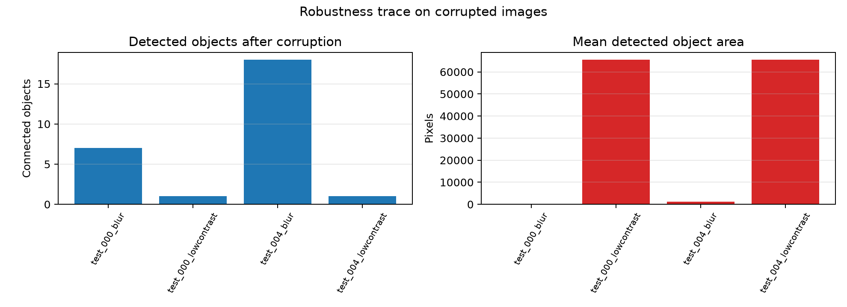
Figure 5. Detected object count and mean object area after blur and low-contrast corruption.
8. Answering the set questions
1. Which description is more useful, and which is more trustworthy — the direct VLM description or the numbers-first description?
The numbers-first description (Task 2) is the more trustworthy of the two, because every word in it traces back to a measurement that was computed from the actual pixels — the model is only allowed to paraphrase numbers it was handed, so it cannot add a visual detail that was never there. The direct VLM description (Task 1) is arguably more useful as a first, human-readable orientation to a new image (“this looks like fluorescence microscopy, quality uncertain”), but it is inherently less checkable, since nothing stops a vision model from describing a feature that is not really in the image. In this project the direct description also came from the deterministic fallback rather than a live model call, which happened to make it perfectly safe here, but for the wrong reason — it was safe because it was not really generating from the image, not because prompting alone solved the trust problem.
2. Did the U-Net improve on classical Otsu segmentation? Give one example each.
Yes, on both Dice (0.989 vs 0.976) and IoU (0.979 vs 0.953), see Table 1. The U-Net's advantage is clearest on crowded images with touching nuclei (Figure 4, row 2) where thresholding alone tends to fuse neighbours into one blob. Otsu's disadvantage nearly disappears on sparse, well-separated fields (Figure 4, row 1), where a simple threshold already isolates each nucleus correctly and the two methods are close.
3. Report your U-Net's Dice and IoU. What do they mean, and where does it make mistakes?
Best validation Dice was 0.989 and validation IoU was 0.979 (reached by epoch 8); on the 12 unseen test images the mean Dice was 0.988 and mean IoU was 0.977. Both scores measure how well the predicted mask overlaps the true mask, from 0 (no overlap) to 1 (pixel-perfect); IoU is the stricter of the two because it also divides by the union rather than the average, so it punishes boundary errors more. Scores this close to 1 mean the model is segmenting almost every nucleus correctly. The mistakes that remain are concentrated at nucleus boundaries in crowded regions (two touching nuclei predicted as one slightly larger blob) and on faint, low-contrast nuclei close to the noise floor, which is also why the most crowded test image (test_004, 42 objects) had the lowest test Dice of the batch.
4. Where in the pipeline can the LLM hallucinate, and what design choices reduce that risk?
The highest-risk point is Task 1, where a vision model looks directly at an image and free-describes it — nothing stops it inventing a tissue type or a clinical impression it was never asked for. The design choices that reduce this are: anchoring the model as descriptive-not-diagnostic in the system text, forcing a fixed JSON schema instead of open prose, and explicitly allowing “uncertain” so the model has a safe answer instead of a forced guess. Task 2 is inherently safer because the model never sees the image at all, only a short numeric summary it must paraphrase, which shrinks the hallucination surface to “misreading the numbers” rather than “inventing new visual facts.” Keeping the structured JSON as the source of truth throughout matters because the narrative sentence is always generated from the JSON, never the other way round — so a reader (or a script) can always check a claim in the narrative against the exact number it came from, and any mismatch is immediately visible rather than buried in prose.

5. Would you trust any part of this system in a real clinical setting? What single change would most improve trustworthiness?
Not on its own, and not yet. The dataset is small and visually simple compared with real clinical slides (uniform staining, little tissue clutter, one modality), the corruption tests here were synthetic and limited to two images, and there is no expert-verified ground truth from an actual clinical workflow. The robustness trace in Section 7 also shows a concrete reason for caution: when the low-contrast image completely broke the mask, the automatic quality_flag still said “acceptable”, because the rule checking it only looks at count and shape, not whether the foreground area is plausible. So the single change I would make first is adding a proper mask-level sanity check — for example, flagging any prediction where the foreground covers an implausibly large or small fraction of the frame — before anything downstream is allowed to call the result “acceptable.” Only after that kind of check is trustworthy, and after testing on a larger and more clinically representative dataset, would any part of this system be worth trusting alongside a human expert, and even then only as a second opinion, never as the final word.
9. Conclusion
This project put four different tools a vision-language model, classical thresholding, a trained U-Net, and a second numbers-only language model into one pipeline where every sentence produced at the end can be traced back to a real measurement. The U-Net outperformed the classical baseline, most clearly on crowded images with touching nuclei, and the full pipeline generalised well from validation to an unseen test set. The most useful lesson came from deliberately breaking an image: it showed that a rule-based quality flag is not automatically reliable, and that keeping structured numbers as the source of truth is only as good as the rules built on top of them. That single gap is also the clearest next step for making the system trustworthy enough to sit next to a human expert.
References
Ronneberger, O., Fischer, P. and Brox, T. (2015) ‘U-Net: Convolutional Networks for Biomedical Image Segmentation’, MICCAI 2015, pp. 234–241.
van der Walt, S. et al. (2014) ‘scikit-image: image processing in Python’, PeerJ, 2, e453.
Otsu, N. (1979) ‘A threshold selection method from gray-level histograms’, IEEE Transactions on Systems, Man, and Cybernetics, 9(1), pp. 62–66.

